**Software Engineering Lab #7**

**Using GitHub**

**Git** is a popular open source version control system. It uses a central server to store files and enable team collaboration. Git can track version information for directories and files. It groups all your changes to files and directories into a *revision*. User can commit changes made to files and directories or revert to a copy of past revision. Tracking changes made by users and comparing different revision of the same file is also possible. In software development, Gitis a distributed revision control and source code management (SCM) system with an emphasis on speed.

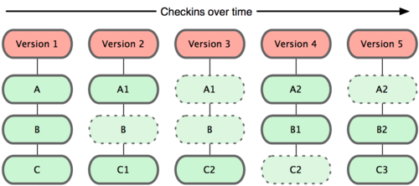

Figure 1 Git stores data as snapshots of the project over time.

Git stores the subversions of any files by keeping all of versions that have been edited at files. In Fig1, there are three files: A, B,and C. If we edited A and B at version 2, then Git will create A1 files as second version of A and C1 as second version of C respectively.

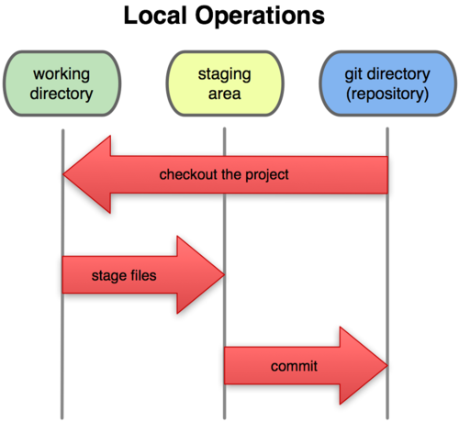

Figure 2 Working directory, staging area, and Git directory.

The basic Git workflow in Figure 2means the sequence of these activities:

* You modify files in your working directory.
* You stage the files, adding snapshots of them to your staging area.
* You do a commit, which takes the files as they are in the staging area and stores that snapshot permanently to your Git directory.

What is GitHub?

GitHub is a web-based hosting service for software development projects that use the Git revision control system.

How to register on GitHub

1. Go to <https://github.com/>, click “Sign up for free” to sign up for your free account by following the steps of registration on the website.

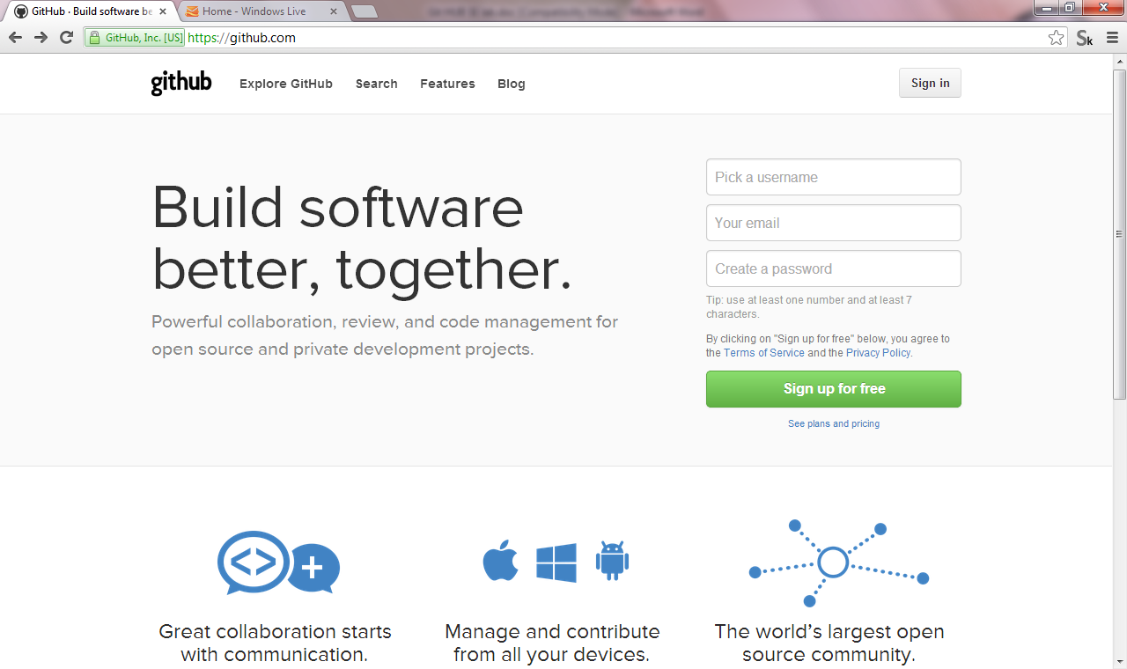

Figure 3 a github’s first page

1. Download Github installer at <https://help.github.com/articles/set-up-git> and install it on your PC.

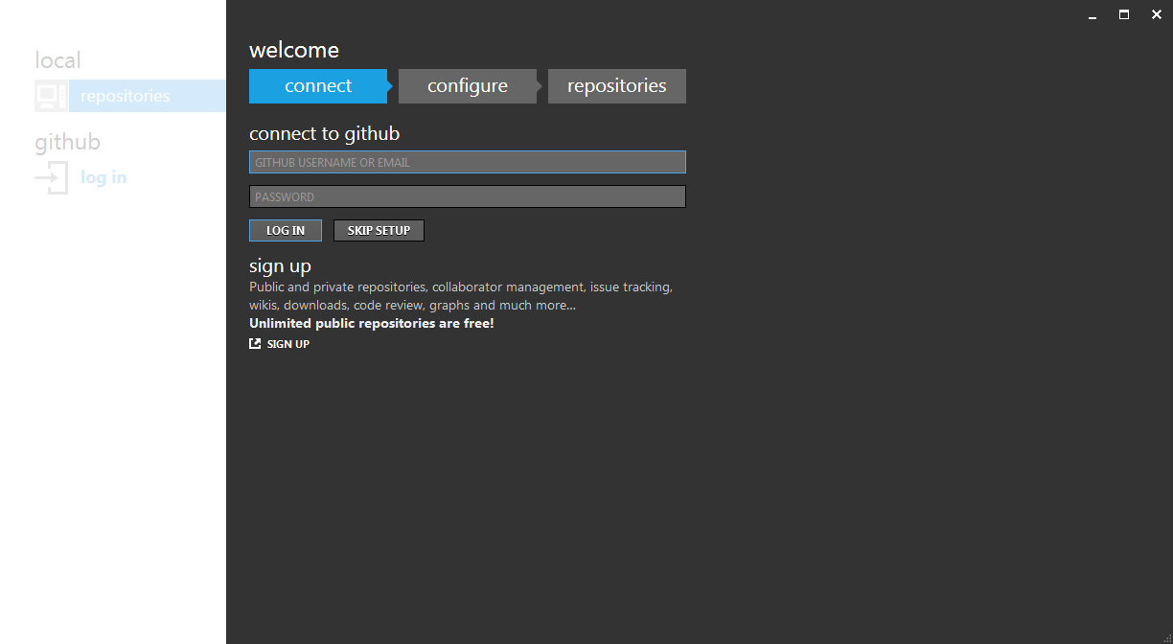

Figure 4github’s software at a login window

1. After the installation has been finished, a login window will appear on your computer (see Figure4).

Login and use GitHub

* Creating a new repository

You can create a new repository using your personal account or an organization account where you have permissions.

* 1. Click “add” button for creating a new repository.

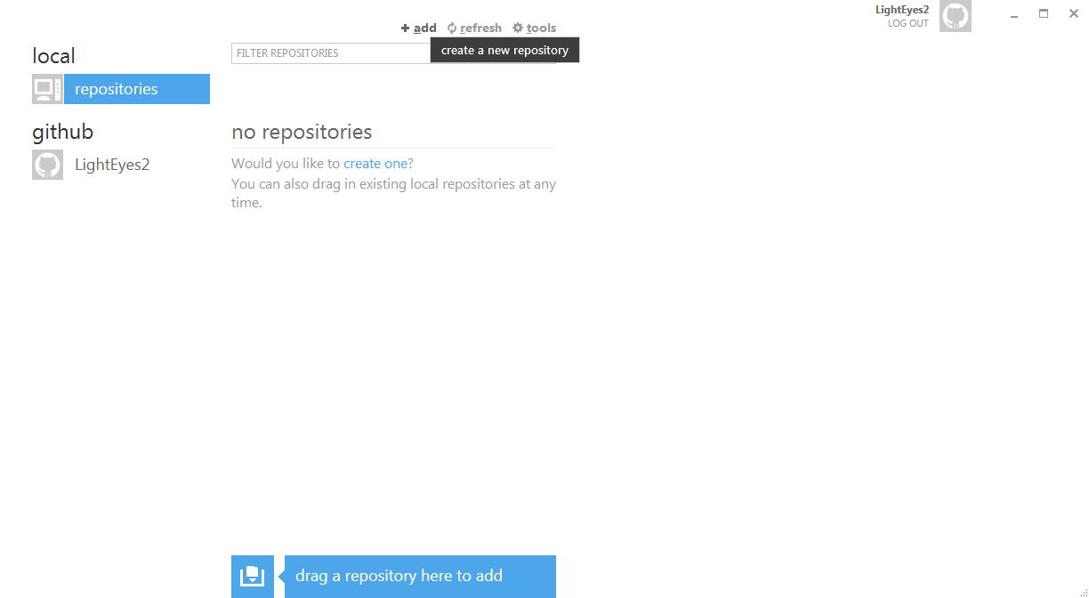

Figure 5 Github’s screen for adding a new repository

* 1. Fill in a new repository name and select the storage directory, then click   
     "create".

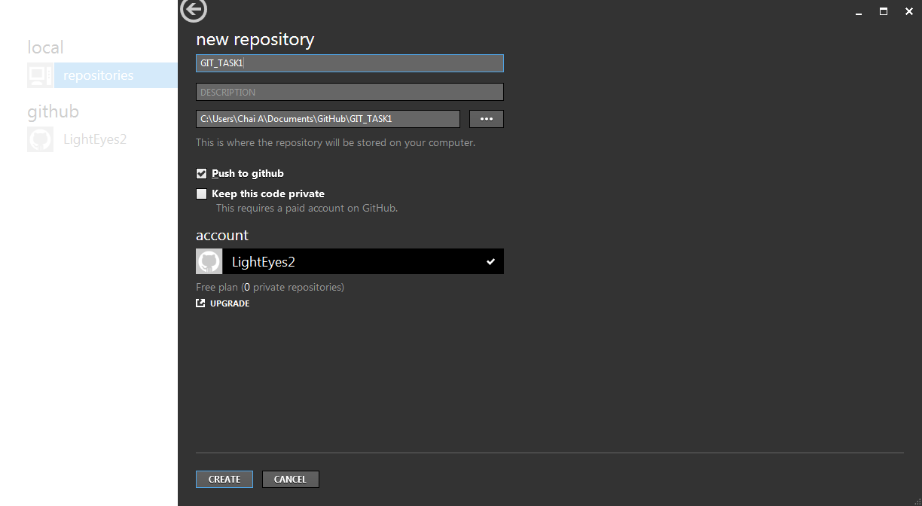

Figure 6 Github’s screen when a user creates a new repository

* 1. Afterward, the repository will appear on the window. (Figure7 repository has a name “GIT_TASK1”)

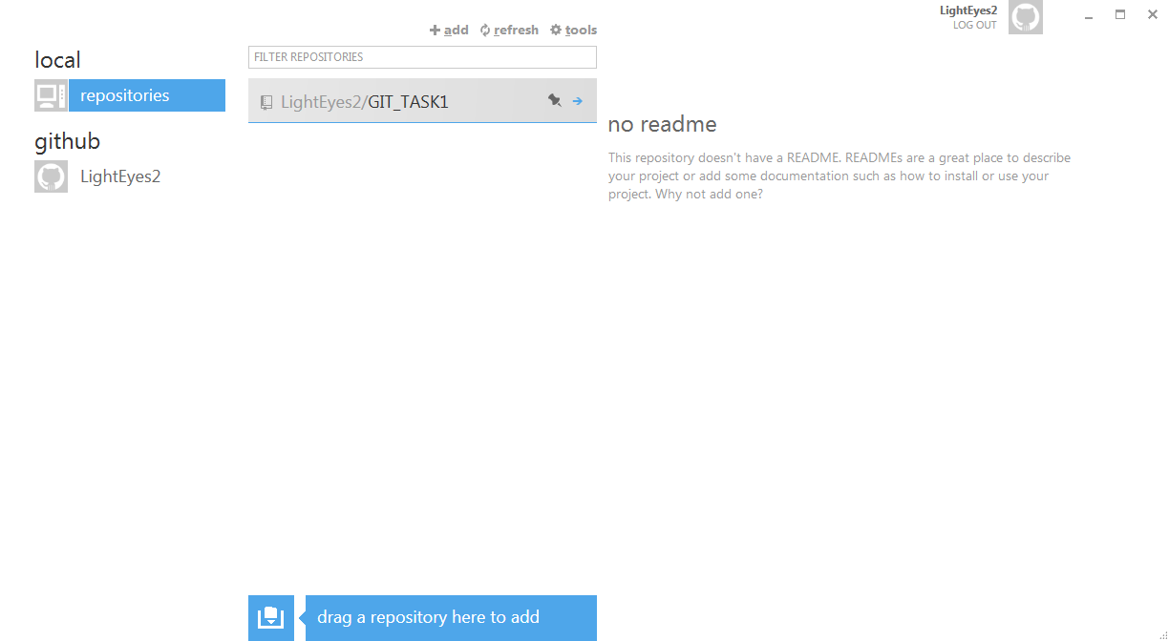

Figure7 Github’s screen with the newly created “GIT_TASK1” repository.

* Commitment

In the repository directory, you can store your files and keep updating their versions from Github software. According to figure 8, Test1.txt has been edited by adding “data1 test” string on the file, while Github keeps updating file’s status and waiting for a commitment. After clicking the commitment button, the file status will be *committed*. If we want to synchronize to the Github server, you can click “publish” button. The Github will report the details of subversion on the history file window (see Figure9). There are revert and rollback functions of any files available on this page.

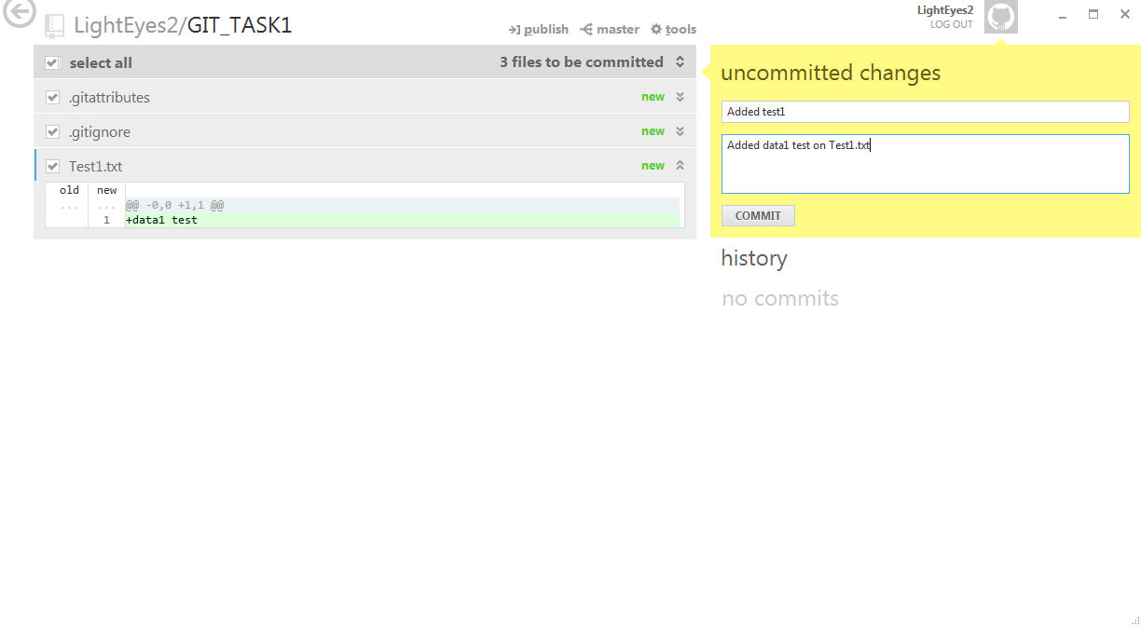Figure8 commitment window

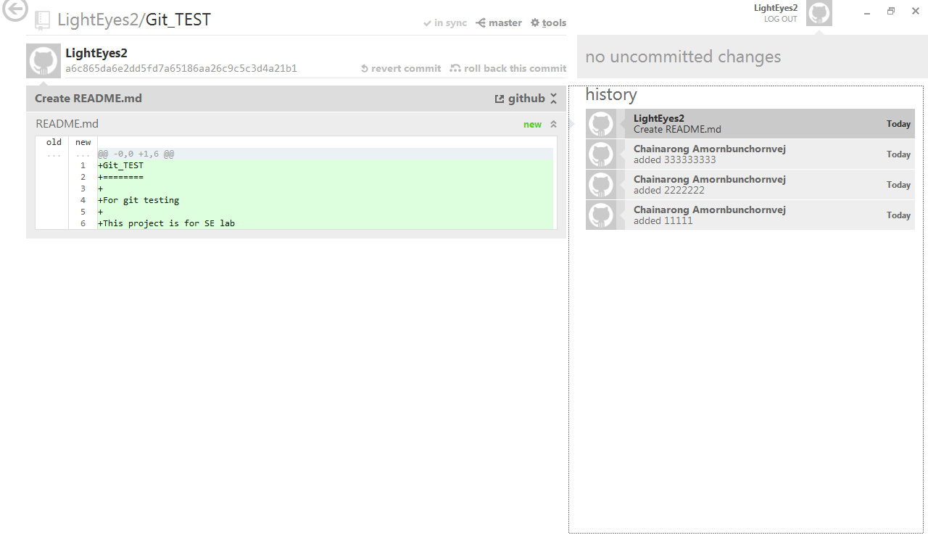

Figure9 History of file window

You can use Github on the website (see Figure10) which provides many functions. After choosing a repository, you can copy your repository by clicking “Clone in window” (see Figure11). You can see the details of subversions on any files at this page. The edit box name “Read+Write access” contains URL is used for sharing your project to your friends.

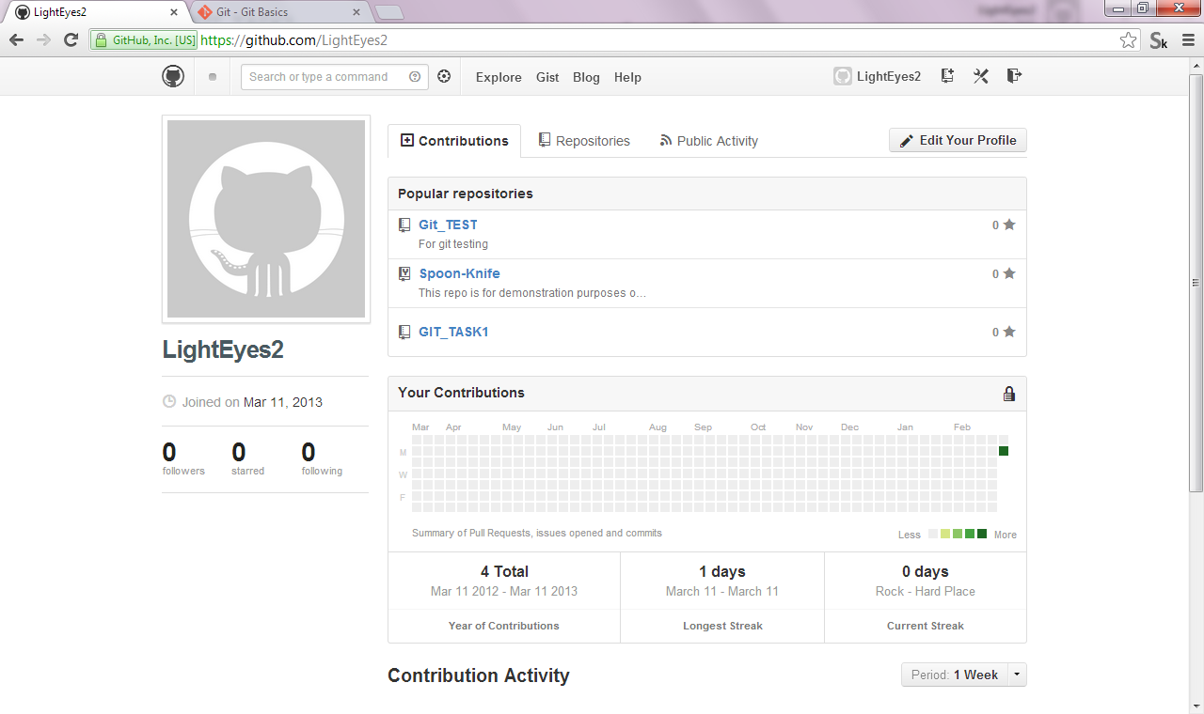

Figure10Github on the website

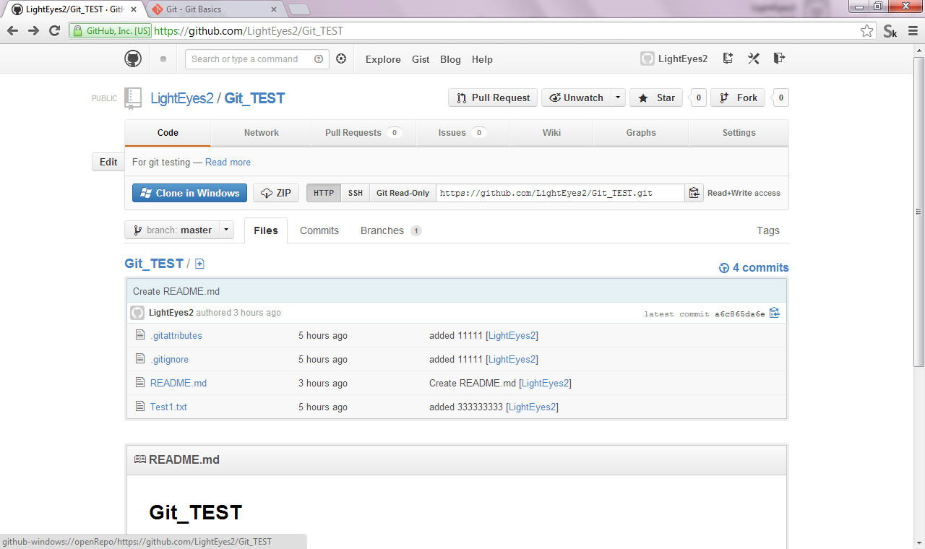

Figure11 repository page on the website.

* Forking

At some point you may find yourself wanting to contribute to someone else's project, or would like to use someone's project as the starting point for your own. This is known as "forking." In this case, we will participate the “https://github.com/octocat/Spoon-Knife” project.

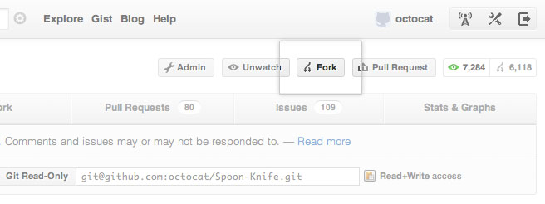

Figure 12 Forking window

* Sharing with your friends

One of the great features on GitHub is the ability to see what other people are working on and who they are connecting with. When you follow someone, you will get notifications on your dashboard about their GitHub activity.

_________________________________